BHS Book-of-the month- August 2024

Read *His Excellency* by Joseph J. Ellis or *The Indispensable Man* by James Thomas Flexner, or substitute your own favorite biography of George Washington.

George Washington is “the father of his country.” “First in War, First in Peace, and First in the Hearts of his countrymen,” Washington fits the bill like no other.

Washington was named Commander in Chief of the Continental Army in 1775 before there was a Continental Army. He had a military record unmatched by his patriot peers. As a young man in the 1750s, he led the Virginia militia protecting the colonists in the Shenandoah Valley. In the French and Indian Wars in the 1760s, he participated with the British in four military campaigns in western Pennsylvania. As a colonial militia officer, he felt a lack of respect from the British hierarchy. It didn’t help that he was passed over for promotion into the British Regular Army.

As a General in the Revolutionary War, Washington did not follow standard European protocol. Rather than surrender when he was outnumbered and out- positioned, Washington developed the art of retreat to fight another day. The British could not win the War if they could not capture Washington or get him to surrender his army. The American patriots rallied in his support. Washington gave hope to his countrymen. The British could not win.

Washington’s dramatic engagements on the field of battle will long be remembered in American history, including the siege of Boston, Valley Forge, Crossing the Delaware, and the surrender of Cornwallis at Yorktown.

As a legislator, Washington served in the Virginia House of Burgesses and the Continental Congress. He represented his neighbors as a farmer, who had to deal with the British merchants in London. As a colonial businessman, he felt the cards were stacked against him.

From the beginning, Washington crafted an impeccable image. Like Benjamin Franklin and Ethan Allen, he created his own persona, as a folk hero—a man of few words, but unquestionable honesty. An excellent horseman with a distinctive stature and countenance, he oozed charisma. By nature, an intelligent man with strong listening skills, he appeared to be a natural leader, well suited for serving as chairman.

Washington was selected Chairman of the Constitutional Convention. There was no close second when it came time to name a President of the United States.

Washington was not known as a speaker but his Farewell Address to his officers at Fraunces Tavern in New York and his Farewell Address following his Presidency were among the most poignant and memorable words of any of the founding fathers.

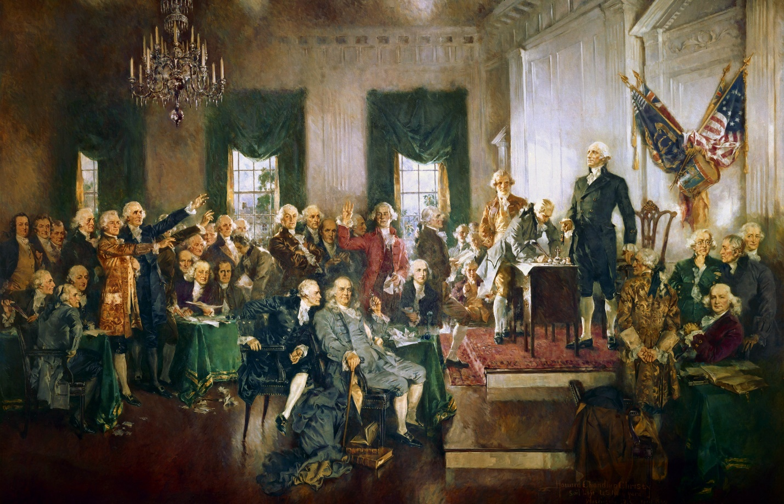

[*Scene at the Signing of the Constitution of the United States*](https://en.wikipedia.org/wiki/Scene_at_the_Signing_of_the_Constitution_of_the_United_States) *by*[*Howard Chandler Christy*](https://en.wikipedia.org/wiki/Howard_Chandler_Christy)